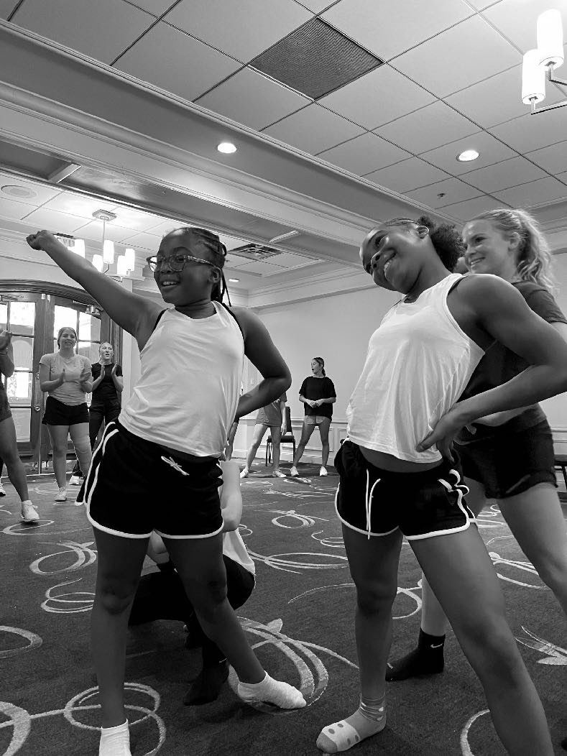

21

SEPTEMBER

2024

Why become

an All Star?

**SELF-CONFIDENCE:**

Through performance and goal setting

**TEAMWORK:**

Work with others towards a common goal

**RESPONSIBILITY:**

Be accountable to your team

**RESPECT:**

For yourself and everyone around you

**DISCIPLINE:**

Values and time management

**STRENGTH:**

Mental and physical

**SOCIAL:**

Meet new friends

**FAMILY:**

That’s what All Star is!

MARK

YOUR CALENDAR!

When All Star unites across the country for a day of cheer and dance, togetherness and fun!

NATIONAL ALL STAR CHEER & DANCE DAY